Network Layer:

Sends the data packets(IP address’+ subnet mask) received from Transport layer

Data Link:

Allows us to directly communicate with the computer. The physical addressing is performed at this layer i.e Mac address is assigned:

Physical Router :

We work with cables and stuff in this layer.

The physical layer receives the data in form of bits and after converting it into electrical signals it transfers to the computers.

Another Model : TCP/IP model

5 layers   
Application> Transport>Network>Data Link>Physical

1. Application Layer: It is the UI (e.g. WhatsApp , Browser) ,which lies on our devices.

* 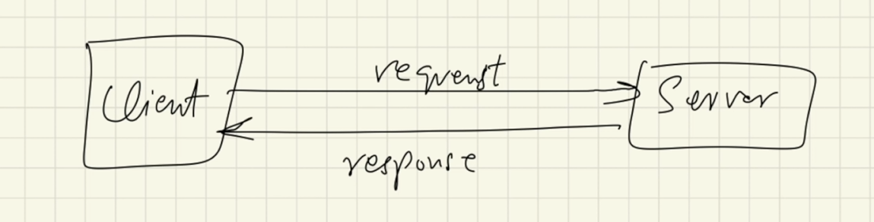
* 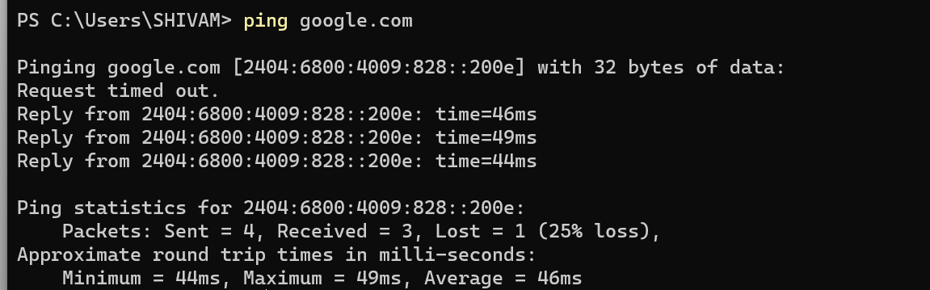
* Peer to Peer (P2P) :Client and server at the same position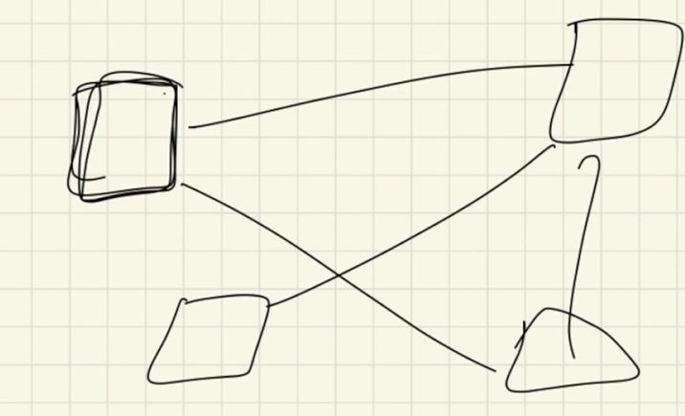

YAML =YAML ain’t markup language

* Data format that exchanges data
* Similar to XML and Json
* Implements Data serialisation : covert object into series if bits that’s easily transferable.